Let’s Think About It!



Dubbo Return to School Program

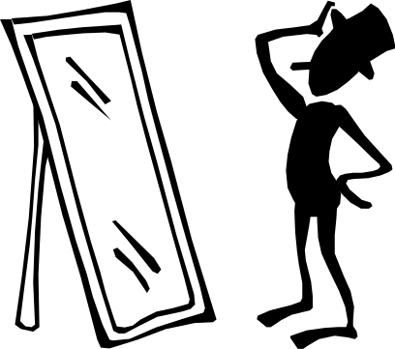

The world is like a mirror. Most of the problems we have with people are because of the way we behave.

When we start to gently change some of our behaviours, people start to see these changes and may like to be near us.

Why are you here?

You have been suspended from attending your school for a period of time because your behaviour has not been acceptable to the school.

This booklet is designed to help you think about what has happened and to start planning for a better time at school in the future. It is up to you whether you want to make the change but you need to realise that we cannot allow you to continue with the behaviour that led to this suspension.

Just like games have rules so that people play fair, schools have to have rules. Suspension is like being sent off during a game. If you get sent off the referee is saying to you that you are not following the rules and unless you are prepared to you can’t continue to play. Being sent off gives you a chance to cool down before you return to the game. If you do something very serious the length of time away from the game may be longer.

Suspension from classes is exactly the same. We are giving you a chance to cool off and to think about the rules before we allow you to return to your classes.

Suspension is a very serious step and it is important that you find out what is going wrong and get some help so that it does not continue. The school has to have rules about what type of behaviour can and can’t be allowed so that it can provide a good learning place for all students.

By working through the following exercises we hope that you will learn a little more about yourself and will return to your classes successfully.

You need to take care of this book. It is your responsibility.

You are here because you made some bad choices. You have not been very helpful to other people. Teachers have the right to teach and students have the right to learn. You do NOT have the right to stop this. That is why you are here. You will still be here if you do not make better decisions and choices.

I CAN WORK IT OUT
State what happened?
____________________________________________________________________________________________________________________________How did you feel?
____________________________________________________________________________________________________________________________What are some different things you could have done that would have not got you suspended? (list 3)
__________________________________________________________________________________________________________________________________________________________________________________________What could you try next time?
______________________________________________________________Who would you like to help achieve this?
___________________________________________________________________________________________________________________________

Who has been affected by your actions and why would they be upset? ____________________________________________________________________________________________________________________________
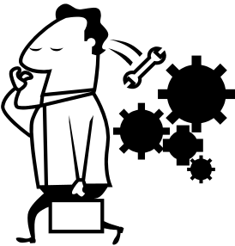
Rules and expectations tasksheet
What rules are necessary for physical safety (of people, belongings and furniture)?  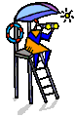 | What rules or expectations are necessary to have people feel they are welcome and belong, and are part of a friendly environment?
What rules do we need to make sure people are free to get on with their work? | What sort of behaviours or responses encourage people to muck around, or break the rules, or treat people badly?  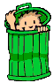

HOW DO YOU RATE?
What is communication?
Communication is more than just using words to tell someone something. Communication also requires the other person to let us know that they hear and understand what we say. It is about sending and receiving messages.
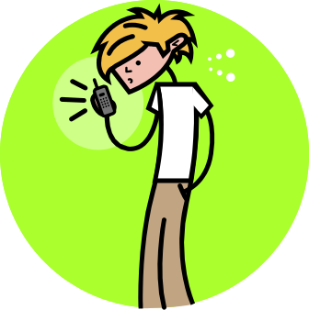
What are two ways we can communicate with others?
1.__________________________
2.__________________________

How often do you use these communications?

 | Often |  | Sometimes |  | Never
 | 1 | 2 | 3 | 4 | 5 | 6
Name calling
Put downs
Blaming
Threatening
Hitting
Bringing up the past
Not listening to the other person
Getting even (revenge)
Hurting someone’s feelings
Not even trying to bend a little
Making yourself look good at the other person’s expense

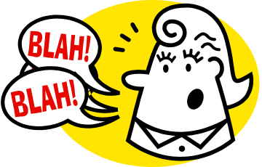
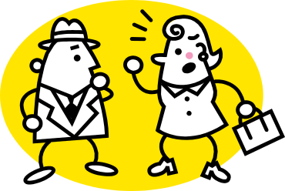
Rights and Responsibilities
What are they?
A RIGHT is something that belongs to you. It cannot be taken away by anyone.
A RESPONSIBILITY is something you should do without being told. Some, you do for others, some for yourself.

Indicate which of the following is a right and which is a responsibility.

 |  | Right | Responsibility
Being thoughtful and courteous of others
Caring for property, your own and other people’s
Being an individual
Being able to express yourself
Accepting school rules
Being safe at school
Being treated with respect
Allowing others to learn

Develop a charter of your rights and responsibilities within a relationship between student and teacher.

My rights | My responsibilities
RESPONSIBILITES

When I am being RESPONSIBLE for my behaviour, then:
 |  | Yes |  | No
Nice things are said to me
I get yelled at
I get picked on
Teachers are polite to me
I feel I am achieving something
I feel happier
I find it easier to do my work
My suspension will be resolved early

When everything is going well at school, I feel ______________________ .

When I am NOT being RESPONSIBLE for my behaviour, then:
 |  | Yes |  | No
I find myself in trouble
My school work is not at its best
My parents are disappointed with me
I feel angry
I fight or argue more
I skip classes

When everything is NOT going well at school, I feel ___________________ .

Who would you like to make you behave in a more reasonable way?
- Someone else
- Myself

Who is responsible for your behaviour? _____________________________
What Makes Me Different?

HOW DO YOU RATE YOURSELF?

Circle the number along each line that best describe you on a scale of
1 = “not like me at all” to 6 = “just like me”
 | 1 | 2 | 3 | 4 | 5 | 6
I complete all my set homework | 1 | 2 | 3 | 4 | 5 | 6
I get on well with the other kids in my year | 1 | 2 | 3 | 4 | 5 | 6
I lose my temper easily | 1 | 2 | 3 | 4 | 5 | 6
I am usually on time for my classes | 1 | 2 | 3 | 4 | 5 | 6
I get involved in fights | 1 | 2 | 3 | 4 | 5 | 6
I have trouble doing the work that I am given | 1 | 2 | 3 | 4 | 5 | 6
I get into trouble for calling out or talking | 1 | 2 | 3 | 4 | 5 | 6
I find school work hard | 1 | 2 | 3 | 4 | 5 | 6
I find it hard to be patient with other people | 1 | 2 | 3 | 4 | 5 | 6
I feel I am learning a lot at school | 1 | 2 | 3 | 4 | 5 | 6
I often swear or call out at others | 1 | 2 | 3 | 4 | 5 | 6
I attend all of my classes | 1 | 2 | 3 | 4 | 5 | 6
I think school is a waste of time | 1 | 2 | 3 | 4 | 5 | 6
I hate being told what to do | 1 | 2 | 3 | 4 | 5 | 6
I know what I want to do when I leave school | 1 | 2 | 3 | 4 | 5 | 6

The characteristics and qualities that make each one of us unique often place us in the situation where we are persecuted or labelled by others. Features that contribute towards individual differences include:

* gender *age *cultural background *disability
* appearance *mental ability *level of health

List the characteristics or features which make you, you?
__________________________________________________________________________________________________________________________________________________________________________________________

What would you like to change in the future from your current answers?
__________________________________________________________________________________________________________________________________________________________________________________________

You are responsible for your own behaviour – you choose!

Your past, your home life or the way other people treat you are not reasons for you to make bad choices.

While you are here, you are responsible for what you do, no matter why you do it. Excuses do not cover up that you have made bad choices on how you behave.

What excuses have you given for your behaviour?
______________________________________________________________________________________________________________________________________________________________________________________________________________________________________________________________________________________________________________________

Have these excuses helped? Why or why not?
______________________________________________________________________________________________________________________________________________________________________________________________________________________________________________________________________________________________________________________

Don’t make bad choices and then make excuses!

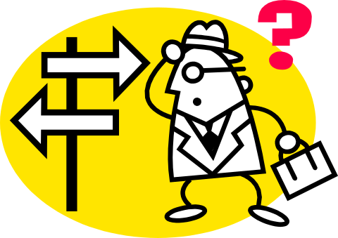
MY SCHOOL

Things I like about my school:

 |  | Like |  | O.K. |  | Dislike
The school rules
Wearing a uniform
Having to do homework
Some of my teachers
Having to complete work
Other students
Sport

Write down some of the things that you like about school:
(They need not be from the list above.)
________________________________________________________________________________________________________________________________________________________________________________________________________________________________________________________

List 3 or more things that have happened to you at school:
(They can be from Infants, Primary or High School.)
________________________________________________________________________________________________________________________________________________________________________________________________________________________________________________________
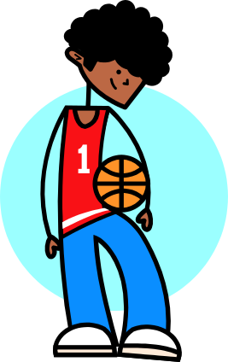
FRIENDS

What do you like most about your friends? __________________________________________________________________________________________________________________________________________________________________________________________

How do your friends help you at school? __________________________________________________________________________________________________________________________________________________________________________________________

How do your friends make it hard for you to do the right thing at school? ________________________________________________________________________________________________________________________________________________________________________________________________________________________________________________________

How do you make it hard for your friends to do the right thing at school? ________________________________________________________________________________________________________________________________________________________________________________________________________________________________________________________

What student/s do you find it hardest to get on with at school? ____________________________________________________________________________________________________________________________

Why are they hard to get along with? __________________________________________________________________________________________________________________________________________________________________________________________

What are two things that are good about this person?
- ________________________________________________________
- ________________________________________________________
What makes you upset or angry outside of school? ________________________________________________________________________________________________________________________________________________________________________________________________________________________________________________________

How does this affect you at school? __________________________________________________________________________________________________________________________________________________________________________________________

How to be a Good Friend

It is very important to be able to make friends and to know how to be a good friend. Everyone likes to have friends and having friend’s helps to make us happy. When you’ve got friends you can have lots of fun with them.

1. Smile at people

2. Say nice things to your friends

3. Ask them to join in games

4. Listen to your friends when they talk to you

5. Think about how your friends feel

6. Play and have fun with your friends

To have a friend you need to be a friend!

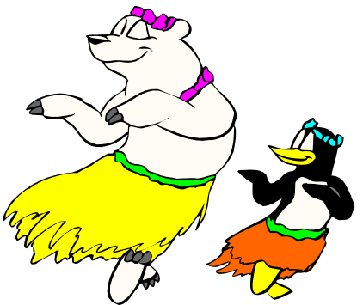
Causing My own Sadness

There are some things about which we feel sad that we cannot control. For example, we cannot control a volcano that erupts and hurts many people.
We also feel sad about some things that we can control. For example, in our anger, we may hurt someone’s feelings.
We cannot control a volcano, but we can control our anger.
Categorise the following causes of sad situations into things which you can control and things that you cannot control. Add at least two items to each list.

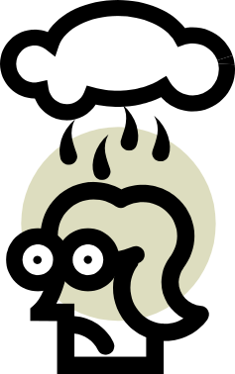
Rain
Jealousy
Fear
Death
Fighting
Fire

Things I can control | Things I cannot control
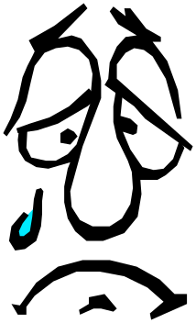
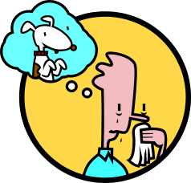
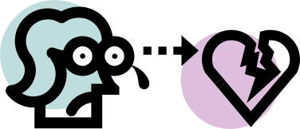
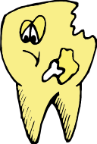
Stress under the surface

When someone is facing a situation of stress or challenge, they may have a mix of feelings underneath the surface.
List in the box a stress that you have encountered recently and circle how you felt in the situation.

The Stress

_____________________________________

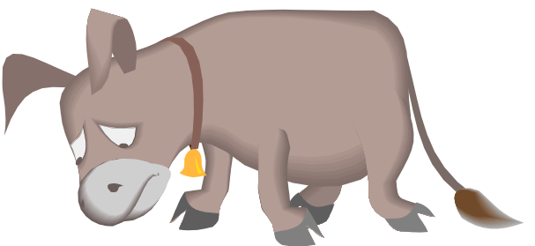
Afraid

Anxious

Unappreciated

Hurt

Defiant

Sad

Let-down

Thwarted

Hopeful

Determined

Angry

Used

Powerless

Lonely

Ashamed

Guilty

Betrayed

Unloved

Proud

Mad

Relieved

Jealous

Rejected

Disappointed

Unwanted

Hey, everyone wants to be happy. Here are some ways to help you be happy.


- Smile!
It makes you look great and friendly
and people will smile back at you!

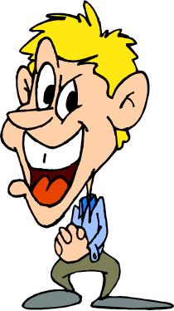
- Say something nice!
It makes other people like you and want to
be your friend if you say nice things to them
and it makes you feel happy too!

- Think happy thoughts.
Think happy thoughts. Think about things you like doing. Think of happy times you’ve had. Think of something funny. Just fill up your head with happy thoughts and you can’t help being happy.

- Cooperate!
It’s a lot easier to be happier if you cooperate with other people and work together; it stops trouble and makes school more fun!
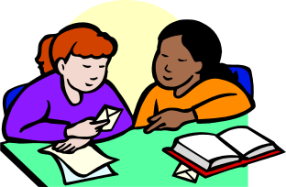

- Play together and have fun!
It’s easier to be happy when you play together.

How People See Me!



How do people see you?
Rate yourself on how you think others see you.
Mark out of 0, with 0 being low, 5 in the middle and 10 high.

Quality | Mark
Quality | How I see myself | Parent/s | Family | Teachers | Friends
Truthful
Always in trouble
Tidy
Reliable
Good at school work
Sensible
Responsible
Able to do a job well
Healthy
Well mannered
Bad tempered
Forgetful
Talkative
Shy
Well adjusted
Helpful
Brainy
Friendly
Trustworthy
Kind
A nuisance
Generous

Rating Reactions

Rate how you might feel if someone said these things to you. Select the face that best descries your reaction and write the number rating in the space provided with a sentence to explain why you might feel that way.

Reaction Rating Scale:
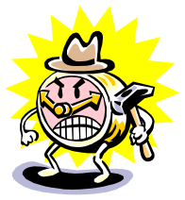
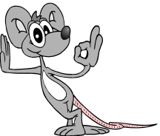
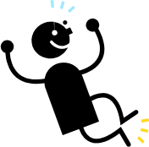


Sad Angry Okay Happy Delighted

 | Rating | Reason
“That’s a nice job. You can be proud of the effort you’ve made!”
“Don’t ask questions! Just do what you are told!”
“I don’t understand. Will you help?”

“I can’t ride my bike with you today. Maybe we can do it tomorrow.”
“I can’t play with you, so go away. I’m busy!”
“This paper is a mess. Why are you so sloppy?”
“Copy this paper over. I know you are proud of your work when it is neat.”
“Congratulations! You got 100% in your maths test.”
“Everyone is having problems with this wok so I want you to do extra homework due in tomorrow!”

How to …. Get Over a Problem

There’s been a problem, things went wrong and I’ve ended up off the rails. I need to sort out the problem, get back on the rails and make a fresh start.
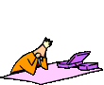
- Cool off!
I may need to leave the room or sit by myself for a while.

- Think.
Either about something I like doing to help me cool off, or about the problem and how it can be solved.
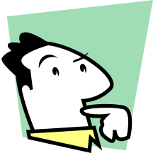

- Talk to someone.
The Principal, the teacher, my mentor or a friend.
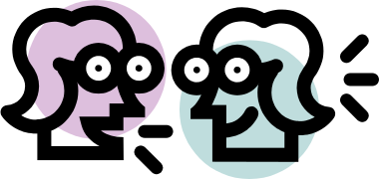

- Say sorry.
If you did something wrong and if you fel able to … otherwise go onto step

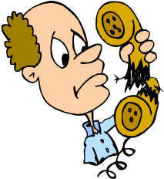
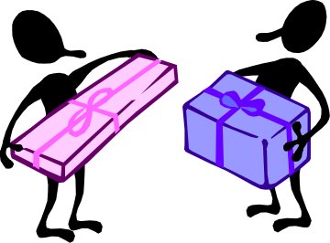

- Make a fresh start.
Take a deep breath and start again.

We can control the way we behave if we want to!
Conflict And Me!

Answer each question as honestly as you can. The purpose of this exercise is to see how you handle conflict situations.

 | Conflict situation | What I usually do | How I feel
1 | When someone calls my mother a name.
2 | When someone blames me for something I didn’t do.
3 | When someone pushes me or hits me for no reason.
4 | When someone steals my pencil or money.
5 | When someone “puts me down” or makes fun of me.
6 | When someone tells me to do something I don’t want to do.
7 | When someone talk behind my back and says things that are lies.

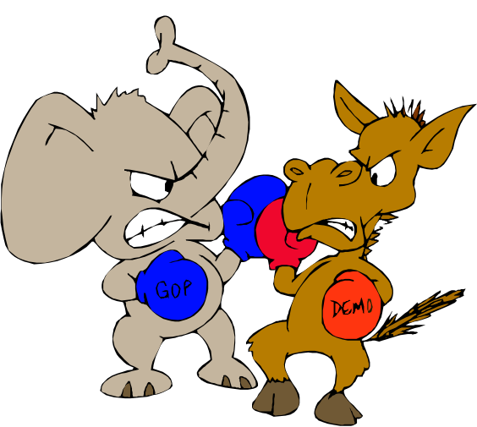
How to … Get on well at school

It is important that we all get along well at school so that we can learn what we need to, get on with each other and be happy. For the school to be a pleasant place we all need to follow these rules:
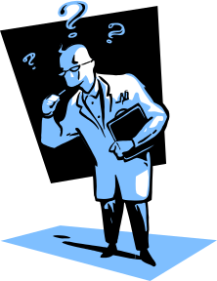

- Do what the teacher asks straight away.
The teacher can’t run the class properly
Unless everyone does this.

- Speak pleasantly to others.
This sets a pleasant tone and makes
everyone feel happy and secure.

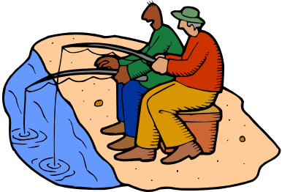
- Co-operate with each other and be friendly
So we can work together and be happy.

- Try hard at your work.
So we can learn as much as we can.

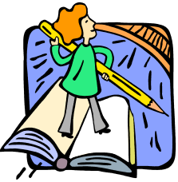

- Leave other people and their belongings alone.

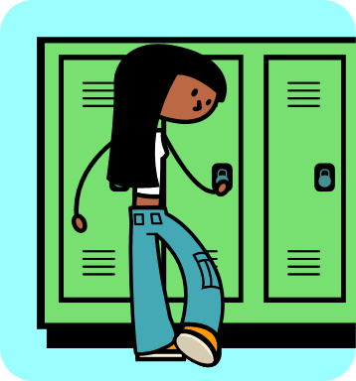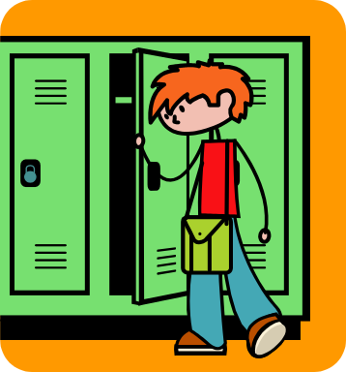
Returning to School

In order to successfully return to classes it is important to think about how you need to change your behaviour so that you can avoid another suspension. Remember that suspension is a very serious step. By suspending you, the school has said that what you are doing will not be accepted and must change. If you don’t change you will affect many opportunities that the school can give you to assist you in the future.

Answer the following questions carefully. You may need to talk to your parents, a teacher or your mentor if you can’t answer them.

Who do you need to speak to as a result of what you did, before returning to school and classes? ____________________________________________________________________________________________________________________________________________________________________________________________________________________________________________

What changes are you going to make so that your behaviour does not break the rules again? _______________________________________________________________________________________________________________________________________________________________________________________________________________________________________________________________________________________________________

Who would you like to have as a supporter to assist you in returning to classes successfully? ____________________________________________________________________________________________________________________________________________________________________________________________________________________________________________

