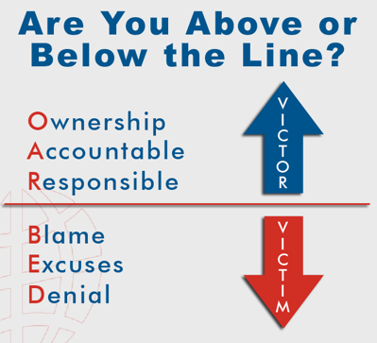
What do you think this picture means in relation to someone’s behaviour?

______________________________________________________________
How does it relate to your behaviour?

______________________________________________________________

Do you accept that your behaviour can be inappropriate at times?
Yes or No

Who is the only person who can control you? _________________________

Do you agree (Yes) or disagree (No) with the following statements?

Statement 1. No-one can help you unless you want to help yourself?
Yes or No

Statement 2. No-one can help you unless you own your behaviour.
Yes or No

Statement 3. Poor behaviour does not mean that you are a bad person.
Yes or No

Statement 4. Everyone makes mistakes, but it is wise to know when we have made a mistake, apologise, learn from the experience and move on.
Yes or No

How to Avoid a Power Struggle
- Take time out. Walk away or step aside if you need to.
- You have choices, making the right choices often helps even if it is something you don’t feel like doing.
- Win-Win, compromise.
- Look on the bright side of life.
- Debrief and mediate. Talk about it once everyone is calm.
- Forgive and forget. Move on from a conflict. Let it go.

